SESSION :- 20

Assignment:--
Submitted by: Dhaval Trivedi (Junior QA Engineer)
1. Agile vs Waterfall — Testing Comparison Table
Factor | Waterfall | Agile
Requirements | Fixed and fully documented upfront (BRS/SRS); testers write test cases only after requirements freeze | Evolve continuously via user stories in the backlog; testers refine test scenarios every sprint as stories change
Feedback cycle | Long — testing happens only after the entire build phase ends, so feedback can take weeks/months | Short — testing happens within each sprint (1–2 weeks), so feedback reaches developers almost immediately
Tester involvement | Testers join late, mostly in the "Testing Phase" as a separate stage after development is "complete" | Testers are involved from day one — in backlog grooming, story writing, and daily standups, alongside developers
Documentation | Heavy — detailed test plans, traceability matrices, and sign-off documents are mandatory before execution | Lightweight — test cases are often just checklists or acceptance criteria attached to user stories; docs evolve as needed
Flexibility | Rigid — once a phase is signed off, going back to change requirements or re-test is costly and discouraged | Flexible — scope can change every sprint; testing adapts continuously as priorities shift
2. Case Study: Zomato — Agile vs Waterfall Testing
If Zomato's QA team followed Waterfall, testing would only start after the entire "order and delivery" module was fully coded — testers would get a huge, finished feature dumped on them near the release date, with little room to push back on design flaws found late.
Under Agile, testing would look very different. Three specific practices that would change:
- Sprint-based regression testing instead of one big test cycle — Instead of one massive regression pass before a yearly release, the QA team would run a focused regression suite (e.g., cart, payment, delivery tracking) at the end of every 2-week sprint, since only a small increment changed.
- Story-level acceptance testing — Each user story (e.g., "Add UPI payment option") would get its own acceptance criteria and test cases written during backlog grooming, and tested as soon as that story is dev-complete — not after the whole payments module is built.
- Continuous exploratory and API testing alongside development — Testers would run exploratory testing and API-level checks (e.g., restaurant search API, delivery ETA API) in parallel with development each sprint, instead of waiting for a fully integrated build, catching integration bugs days instead of weeks later.
A fourth practical shift: bug triage would happen daily in standups rather than in a formal end-of-phase bug review meeting, so fixes get prioritized and retested within the same sprint.
3. Scrum Roles & Ceremonies
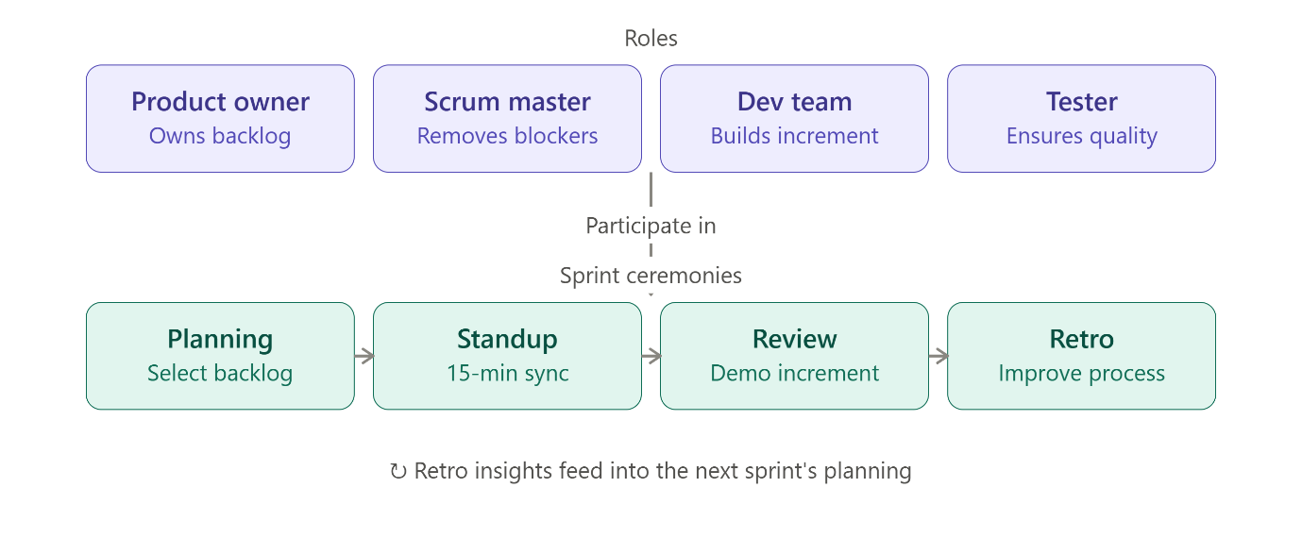
(see diagram above) — Product Owner, Scrum Master, Dev Team, and Tester all participate in the recurring cycle of Sprint Planning → Daily Standup → Sprint Review → Retrospective, with retro insights feeding into the next sprint's planning.

4. Testing Activities Across a Swiggy Sprint
Sprint phase | Testing activities
Backlog grooming | Tester reviews upcoming user stories (e.g., "Live order tracking on map") for testability; raises questions on ambiguous acceptance criteria; estimates testing effort
Sprint planning | Tester helps break stories into testable tasks; defines acceptance criteria jointly with Product Owner; plans which stories need automation vs manual testing
Development (mid-sprint) | Tester writes test cases (functional, edge cases, negative scenarios) in parallel with coding; performs early API testing on completed endpoints (e.g., restaurant menu API); pairs with devs for quick clarification
Story completion → test execution | Tester executes functional, UI, and integration test cases as soon as a story is marked "dev complete"; logs bugs immediately in the tracker (e.g., Jira) with severity/priority
Bug fixing loop | Tester retests fixed bugs same day; runs quick smoke tests on affected areas (e.g., checkout flow after a payment bug fix)
Pre-review regression | Tester runs a targeted regression suite covering the sprint's changed areas plus critical paths (login, cart, order placement, payment)
Sprint review | Tester demos tested features alongside devs; notes any known issues or edge cases to stakeholders/Product Owner
Sprint retrospective | Tester shares testing pain points (e.g., "too many late-arriving stories," "flaky test environment") and suggests process improvements (e.g., earlier API mocking, better test data)

